FLOWCHART

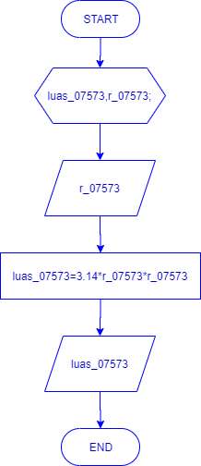

#include <iostream>

#include <math.h>

using namespace std;

int main () {

float luas_07573,r_07573;

cout <<"## Menghitung Luas Lingkaran ##" <<endl;

cout <<"===============================" <<endl;

cout <<endl;

cout <<"masukan r_07573: " <<endl;

cin >> r_07573;

luas_07573=3.14*r_07573*r_07573;

cout <<"hasil luas_07573: " << luas_07573 <<endl;

cout <<endl;

return 0;

}